**Pathfinder Tax Calculation Customizations 2.0**

# 1. Objects Modified

|  |  |  |
| --- | --- | --- |
| **Object Type** | **Object ID** | **Object Name** |
| Codeunit | 37032330 | Payroll Calculation |

# 2. Code Updates

2.1. Method: CalculateDependentTax() - Codeunit PayrollCalculation

Changes: Updated Method

Purpose: To lookup tax bracket using Adjusted Amount i.e. Taxable amount

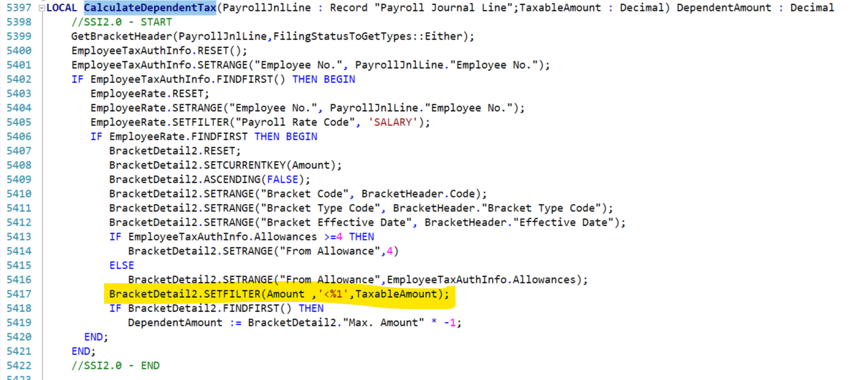

2.2. Switch Case: 500 - APPLY DEPENDENT BRKT

Changes: Updated Switch Case

Purpose: To get the dependents tax amount into Temp Amount bucket.

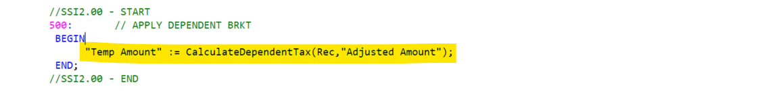

2.3. Bracket Details – TEST DEP

Changes: Updated TEST DEP Bracket

Purpose: Updated bracket number from annual to monthly values.

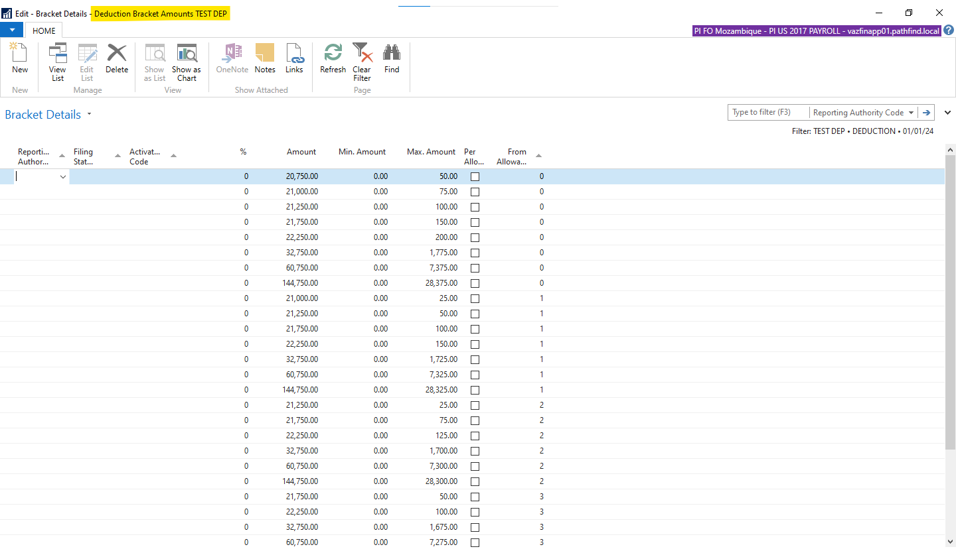

# 4. Screenshots

## Stack Trace

